# Website Planning:

## Pre-planning:

Simple sketch of what our site will look like:

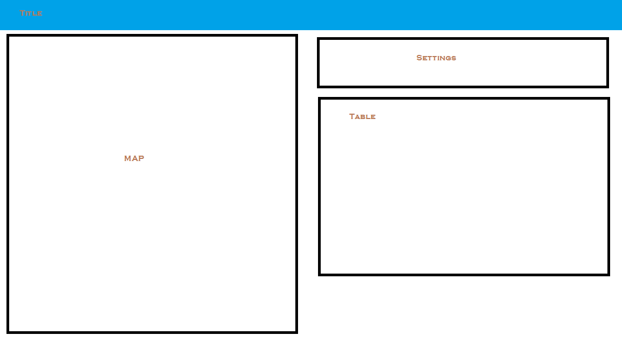

Using a framework tool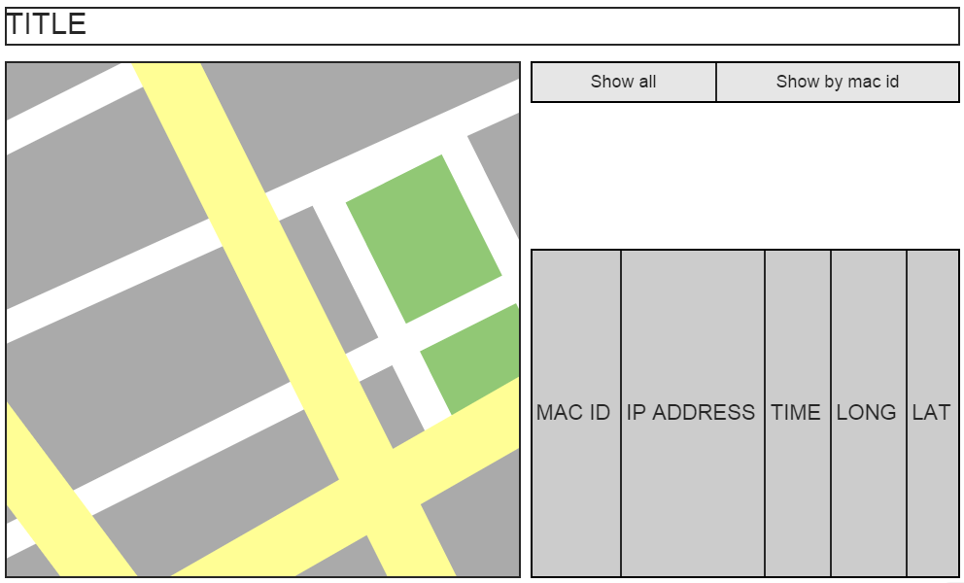

# Psuedocode

## Index.html:

Header

Import js

Import css stuff

Body

Title cssed with banner

Left div

Map

Right div

Setting buttons

Table

## Gmaps.js

Initialize

Create google map

Set center to BCIT

Generate table headers

Set mode to most recent markers

Load most recent markers

Refresh

Delete all current markers

If mode is “all current”

Load most recent markers

else

Load markers by mac id

Delete all markers

Delete rows from table

Go through array of current markers and remove markers

Most recent markers

Load xml doc

Parse xml into array

If it’s a new mac id

Add to array

If it’s an existing mac id

Override old entry

Create markers

Make table row

Load Mac History markers ( mac id )

Load xml doc

Parse xml into array

If xml element mac id == mac id

Place markers

Add table rows

Set mode to all current

Mode = all Current

Refresh

Set mode to mac id

Get text from textbox

Mode = text

Refresh

Refresh

Set interval to call refresh

Refresh Off

Remove interval to call refresh

# Bonus: Server Configuration

For this assignment, we have had Alex setup the website and server on a raspberry pi.

* <http://lamckalex.ddns.net/GPSAssign/>
* Login: dcomm
* Password: bcit

The configuration was as follows:

* Setup SSH
* Setup apache
* Setup .htaccess and .htpasswd

Setup Port Forwarding:

* Port ??? was forwarded for ssh.
* Port 80 was forwarded for the website
* Port 7000 was forwarded for the server
* 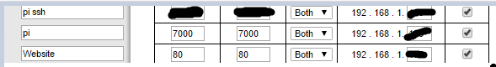

To solve the issue with the IP being possible changed

* We have setup a domain with No-IP
* No-IP is a free service that can be installed onto the raspberry pi, it will provide updates to the server with its IP Address, and this allows the website to know what the correct IP for the server is even if the ISP decides to change the IP for the Raspberry Pi.

The server was then compiled on the Raspberry Pi and it is not running 24/7.

* 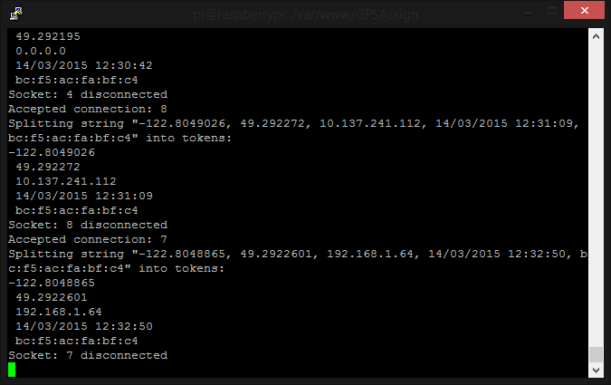

Resources:

<http://www.instructables.com/id/Host-your-website-on-Raspberry-pi/?ALLSTEPS>

<http://httpd.apache.org/docs/2.2/howto/auth.html>